

Aaheli

Inventory Management System



Project Guide

**Mrs. Chitra Nagarkar**

Project Members

**12856 Saurabh Deo**

**12857 Ishita Koske**

**12858 Kaustubh Khairnar**

**12859 Darshana Rathi**

**Department of Computer Science**

This is to certify that a team of students,

Khairnar Kaustubh Vijay (12858), Deo Saurabh Santosh(12856),



Rathi Darshana Deepak (12859), Koske Ishita Vishal (12857)

has successfully completed a project work as a part of SEM VI,

T. Y. B. Sc. (Computer Science) course under the guidance of Mrs. Chitra Nagarkar in the academic year 2021-22.

Project Title: Inventory Management System for food-manufacturing unit (Aaheli).

Project Guide Head

Mrs. Chitra Nagarkar

Internal Examiner External Examiner

Index

|  |  |  |
| --- | --- | --- |
| Sr. No. | Content | Page No. |
| 1. | Acknowledgement | 4 |
| 2. | Introduction | 5 |
| 3. | Existing System | 6 |
| 4. | Scope of the system | 7 |
| 5. | Feature of the system | 8 |
| 6. | System Requirement   * Hardware * Software | 9 |
| 7. | Feasibility study   * Technical Feasibility * Economic Feasibility * Operational Feasibility | 10 |
| 8. | Analysis and Design   * ER Diagram * UML Diagram | 11-20 |
| 9. | Data Dictionary | 21-23 |
| 10. | Input-Output Screen | 24-28 |
| 11. | Limitations/Drawbacks | 29 |
| 12. | Future Enhancement | 30 |
| 13. | Bibliography | 31 |

Acknowledgement

We would like to express our greatest appreciation to all the individuals who have supported us throughout the project. We are thankful to Chitra Nagarkar ma’am for her ongoing support during the project, from initial advice, and showing us the path, which led to the final report of this project.

A special acknowledgement goes to all our folks who shared their ideas, which gave us a different perspective to look at the system and our idea.

We wish to thank all my teachers who were there for any query or confusion we had regarding any topic. They were always there for us whenever needed.

Introduction

This system is for Aaheli food manufacturing unit. Aaheli is located at Aurangabad, Maharashtra. Aaheli manufactures food products for companies / customers who has their recipes but need a manufacturer to process it in large quantity. It’s a B2B company.

This system is an inventory management system which would help the client to manage its stock, recipes and orders. It’s a system which would reduce the manual work of updating the stock and checking it.

In this system user can add new recipes, update stock details, maintain supplier details, update status of current order, store and get recipes for multiple recipes. This system will also provide a service to the customers of Aaheli. Where they can place order, check status of their order, navigate through their previous order.

Existing System

Existing system of Aaheli works manually. They update and maintains stock on pen and paper basis. All the orders are given by mail and updates of that order are communicated through phone call or using messaging services.

List of Suppliers and the stock collected from them is also maintained on pen and paper system. Previous purchased stock, new purchased stock all are maintained in a notebook.

Orders are maintained and processed manually. Past orders are maintained in a notebook. Correct recipes for every different batch and calculated manually through calculators. After the delivery of the material batch no. and other details of the product are stored manually.

Scope of the system

Our system is providing interface for management of inventory for food manufacturing unit. User can add and manipulate recipes and stocks.

User can add recipes, manipulate recipes, get recipes with exact quantity for different batch. User can also view their customer details, view order given by their customers, update status of that order, view stock availability, update stock.

There are many functionalities for the user’s customer also. Customer can place order, view previous orders, add their recipes, view those recipes, check the status of the order they have given. They can also update their own company details like delivery address, phone number, email address.

Our system will help the manufacturer to make their clerical work easy with little bit of computation. User would be able to see their previous details of stock purchased, order delivered and other details. It would also provide and interface for the user’s customer to place order and view its details.

Feature of the system

* This system is convenient for clients of food manufacturing unit.
* Most of the clerical work would be done by the system.
* Calculation work would be done by the system.
* Storing of the data would be lot more organized and structured.
* Accepting and processing of the order would be done by the system.
* Stock maintenance and availability check could be done with just a click in the system.
* Recipes would be stored and displayed whenever required to the user.
* Easy to use interface so that anyone can handle the system with an ease.
* Conversion from percentage to actual quantities in required units is of ingredients for recipes is taken care of by system.

System Requirements

* **Hardware**

This System can work on any system with minimal specification and a stable internet connection. There is no excessive graphical requirement from the system. Any Operating System above Windows Vista could handle this system with minimal graphics.

* Windows 7, Windows 8, Windows 8.1, Windows 10 or later
* An Intel Pentium 4 processor or later that's SSE3 capable
* **Software**
* This system would require a general Web Browser like Google Chrome, Mozilla Firefox, Internet Explorer, Microsoft Edge, Brave, TOR.
* Microsoft Windows 10 and newer  
  + Google Chrome (latest stable version)
  + Firefox (latest stable version)
  + Microsoft Edge (latest stable version; Chromium-based only)
* MacOS 10.12 and newer
  + Google Chrome (latest stable version)
  + Safari (latest stable version)

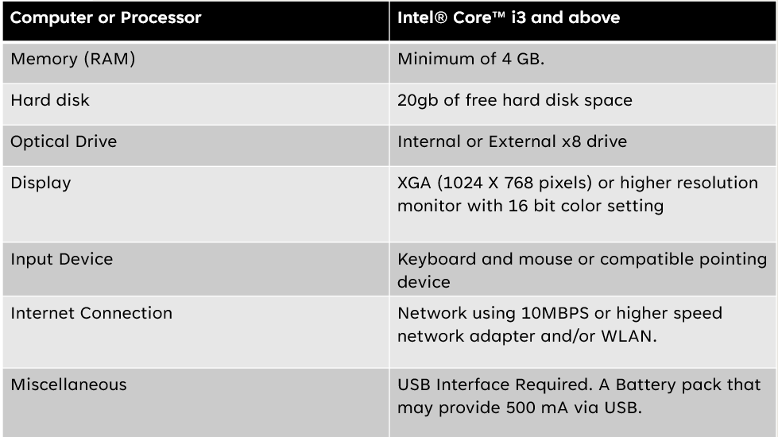

Feasibility Study

* **Technical Feasibility:**
  + There are not excess software or hardware requirements for the system so it can be easily accessed.
  + A stable internet connection is must.
  + The system could work on basic computer with a web browser.
  + No excess graphics are required to access the system.
* **Economic Feasibility:**
  + It’s a cost-effective system, just a stable internet connection would be a charge to the user.
  + Regular computer maintenance would help the system to perform better.
  + A single person who has basic knowledge of computer could handle this system efficiently, so labor cost would decrease.
  + This system has been built upon open-source systems.
  + Hosting charges for the website will be incurred 3$/ month
* **Operational Feasibility:**
  + A person with basic computer knowledge could handle the system with efficiency.
  + The system is user friendly so no excess training would is required to be given.

**Analysis and Design**

**E-R Diagram**

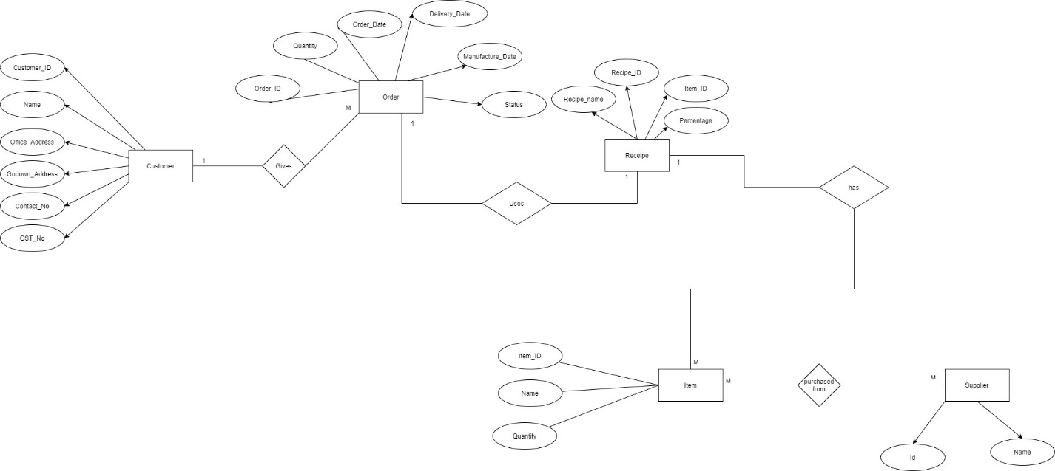

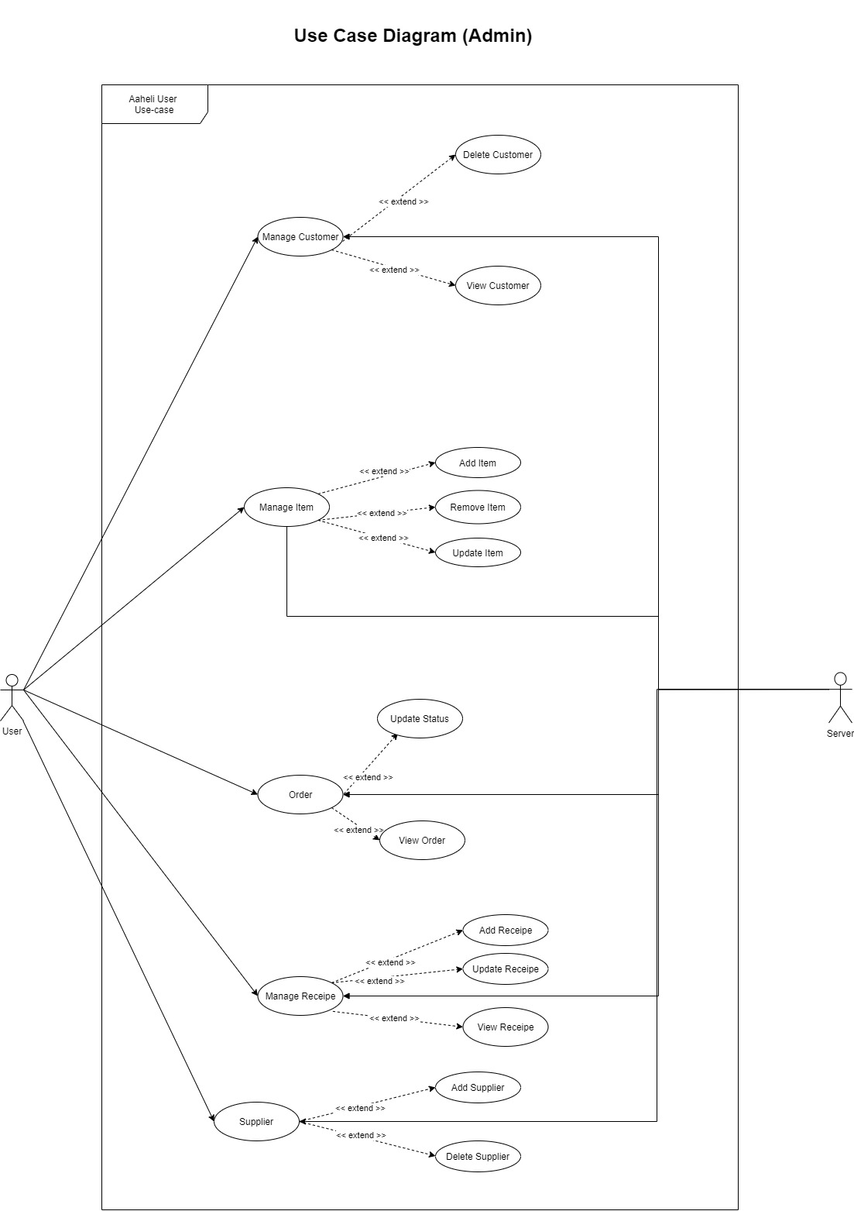

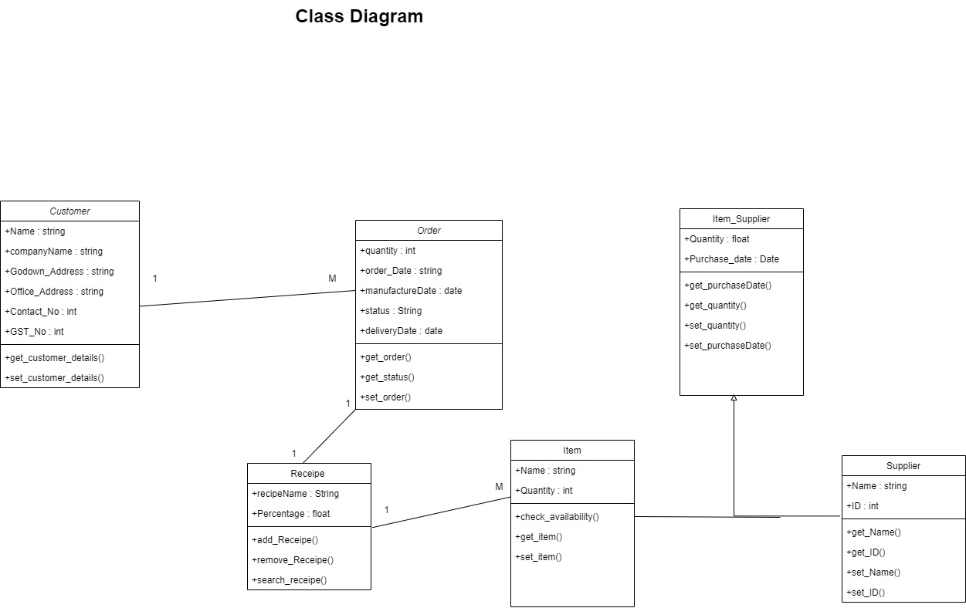

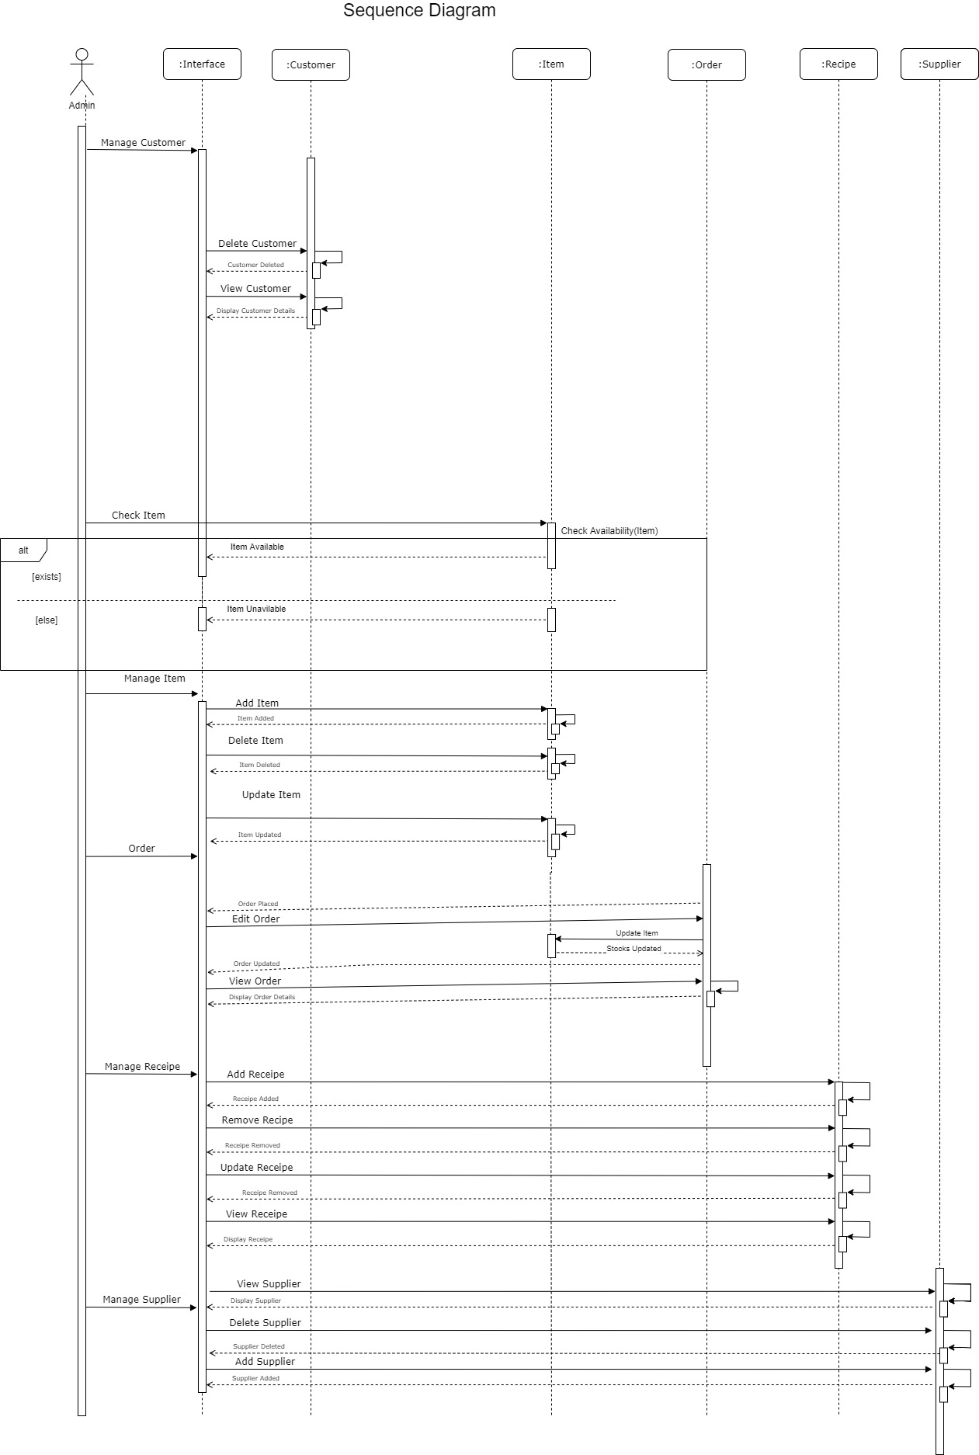

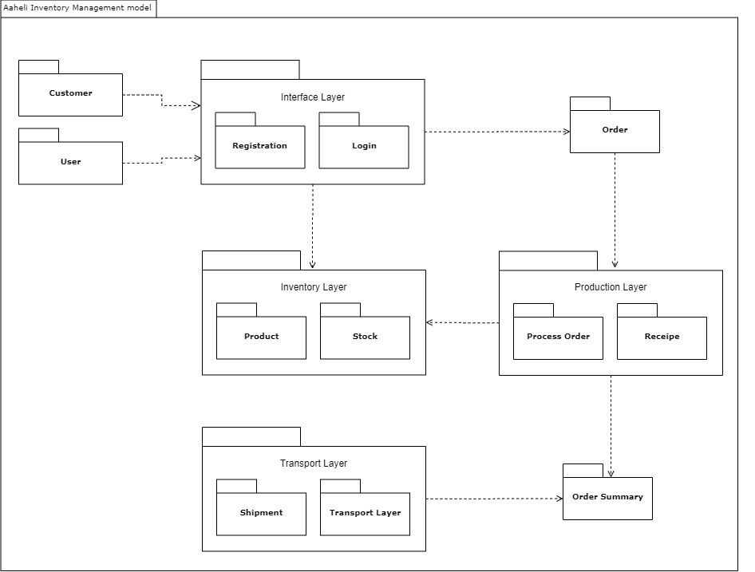**Package Diagram**

**Activity Diagram**

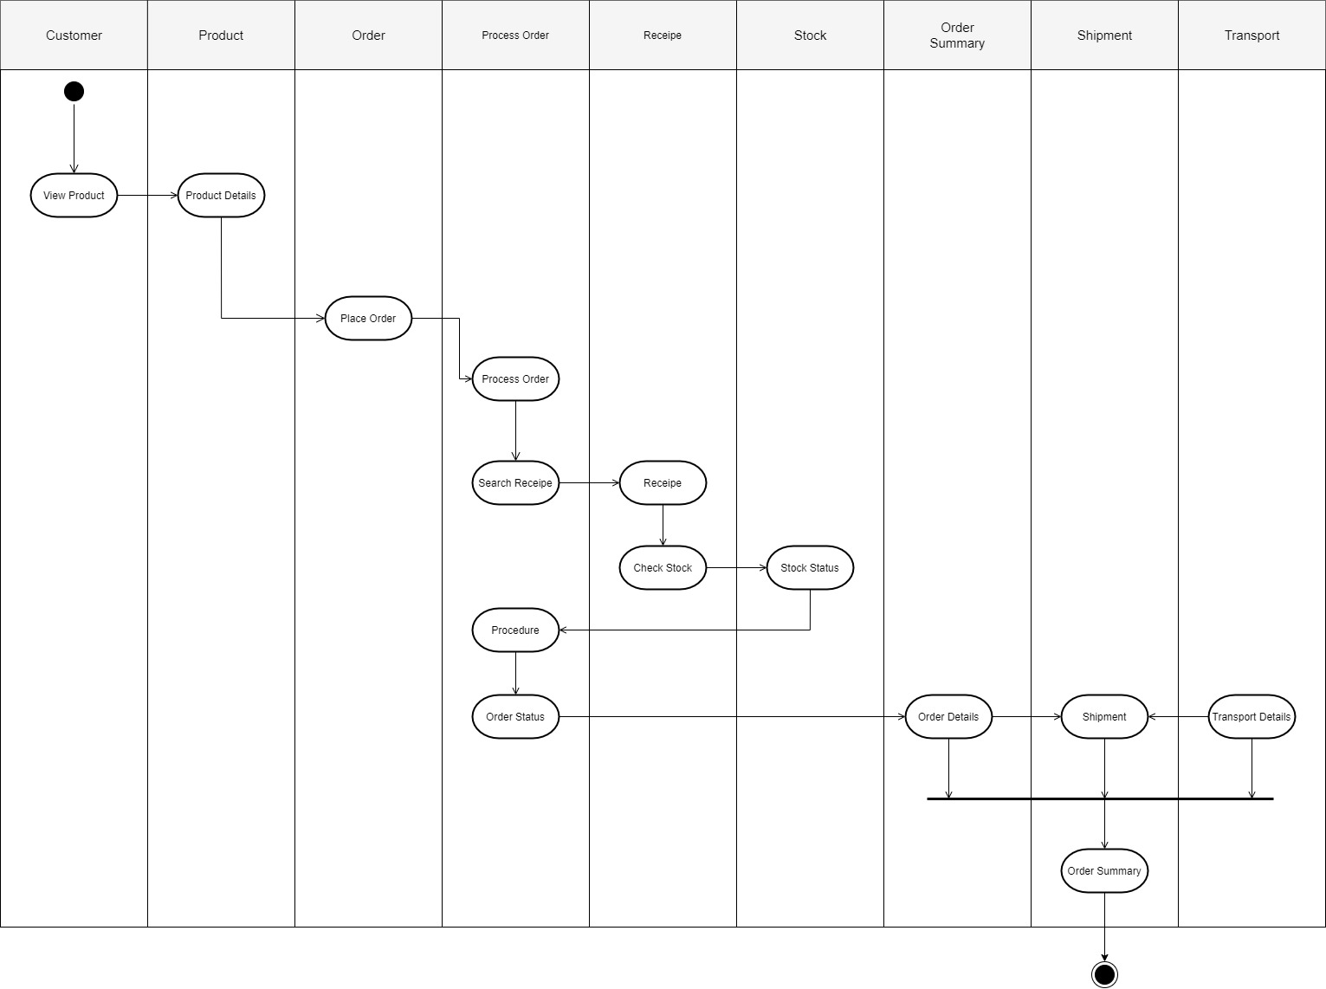

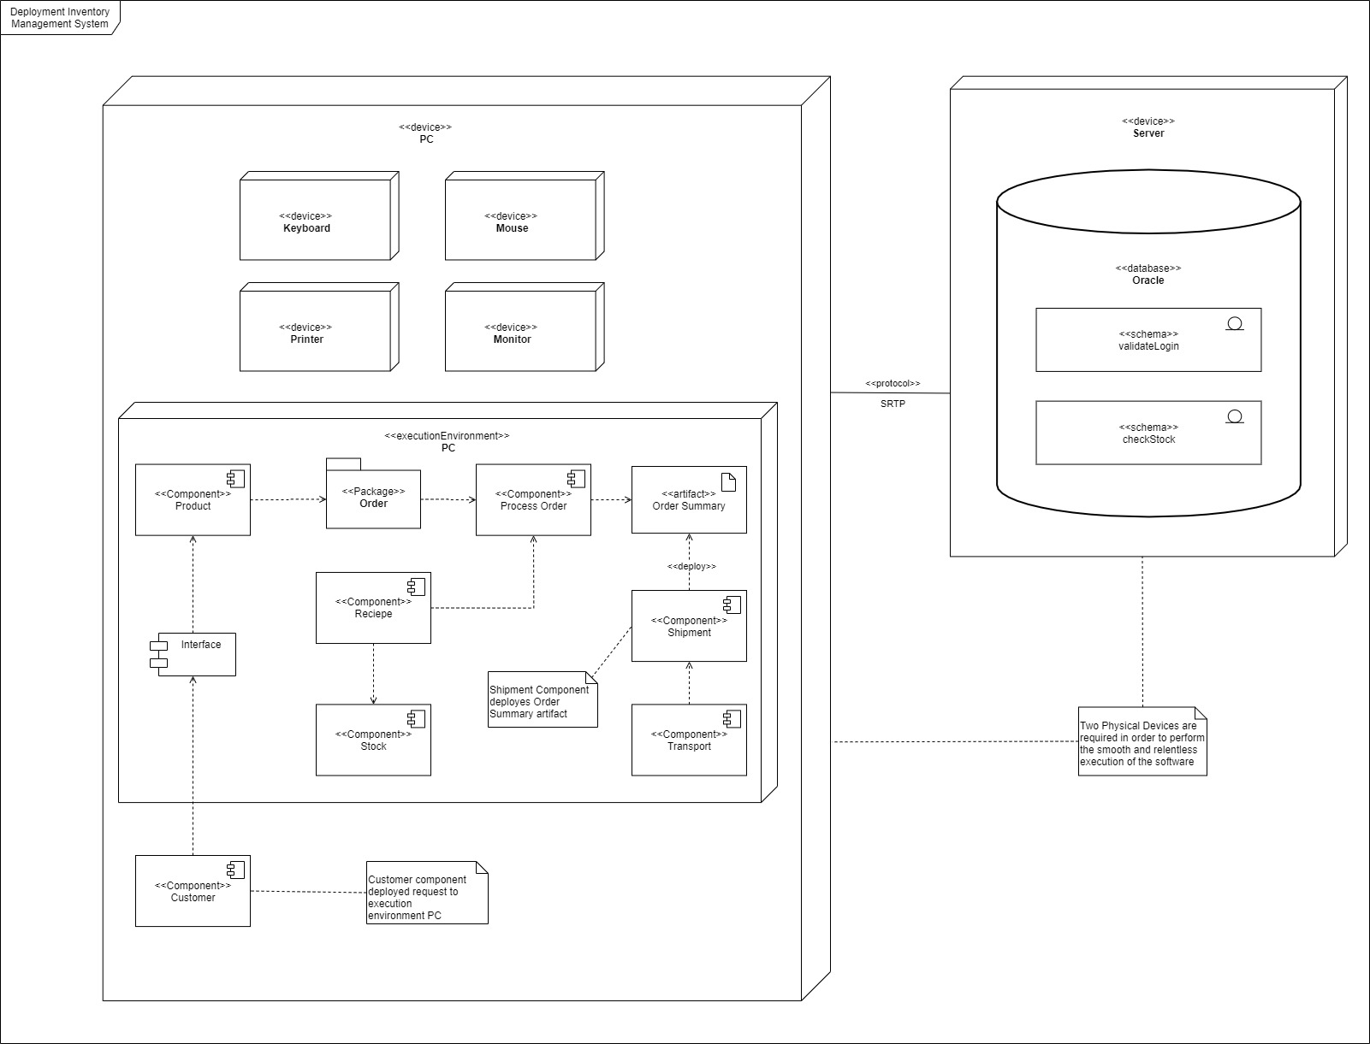**Deployment Diagram**

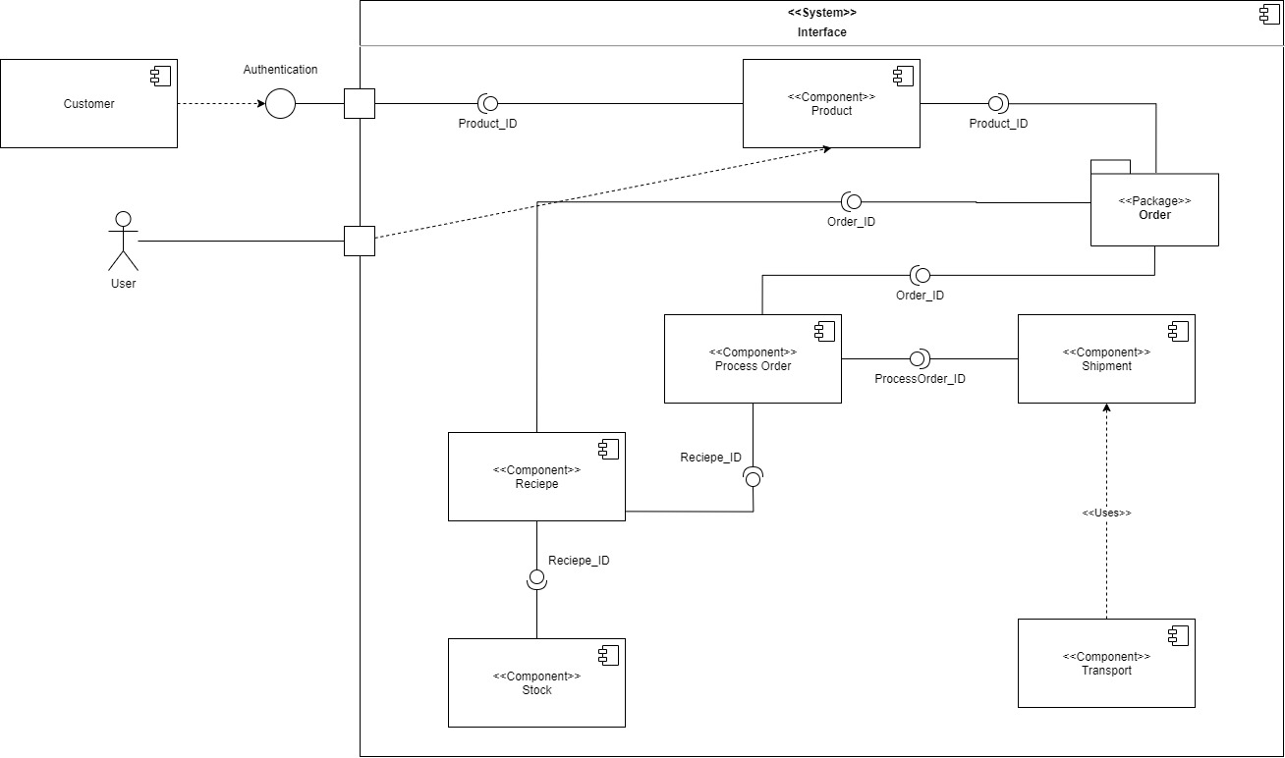**Component Diagram**

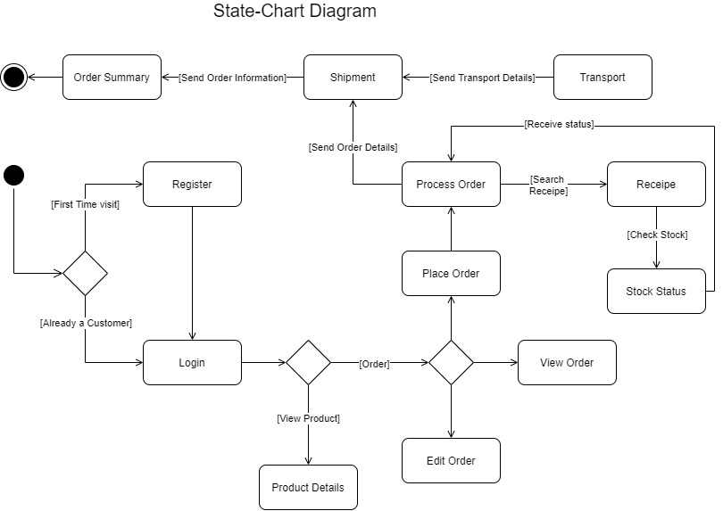**State-Chart Diagram**

**Collaboration Diagram**

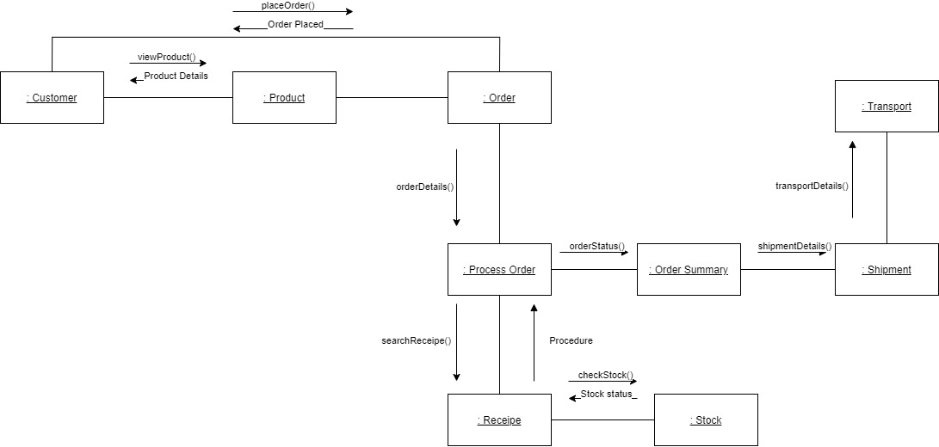

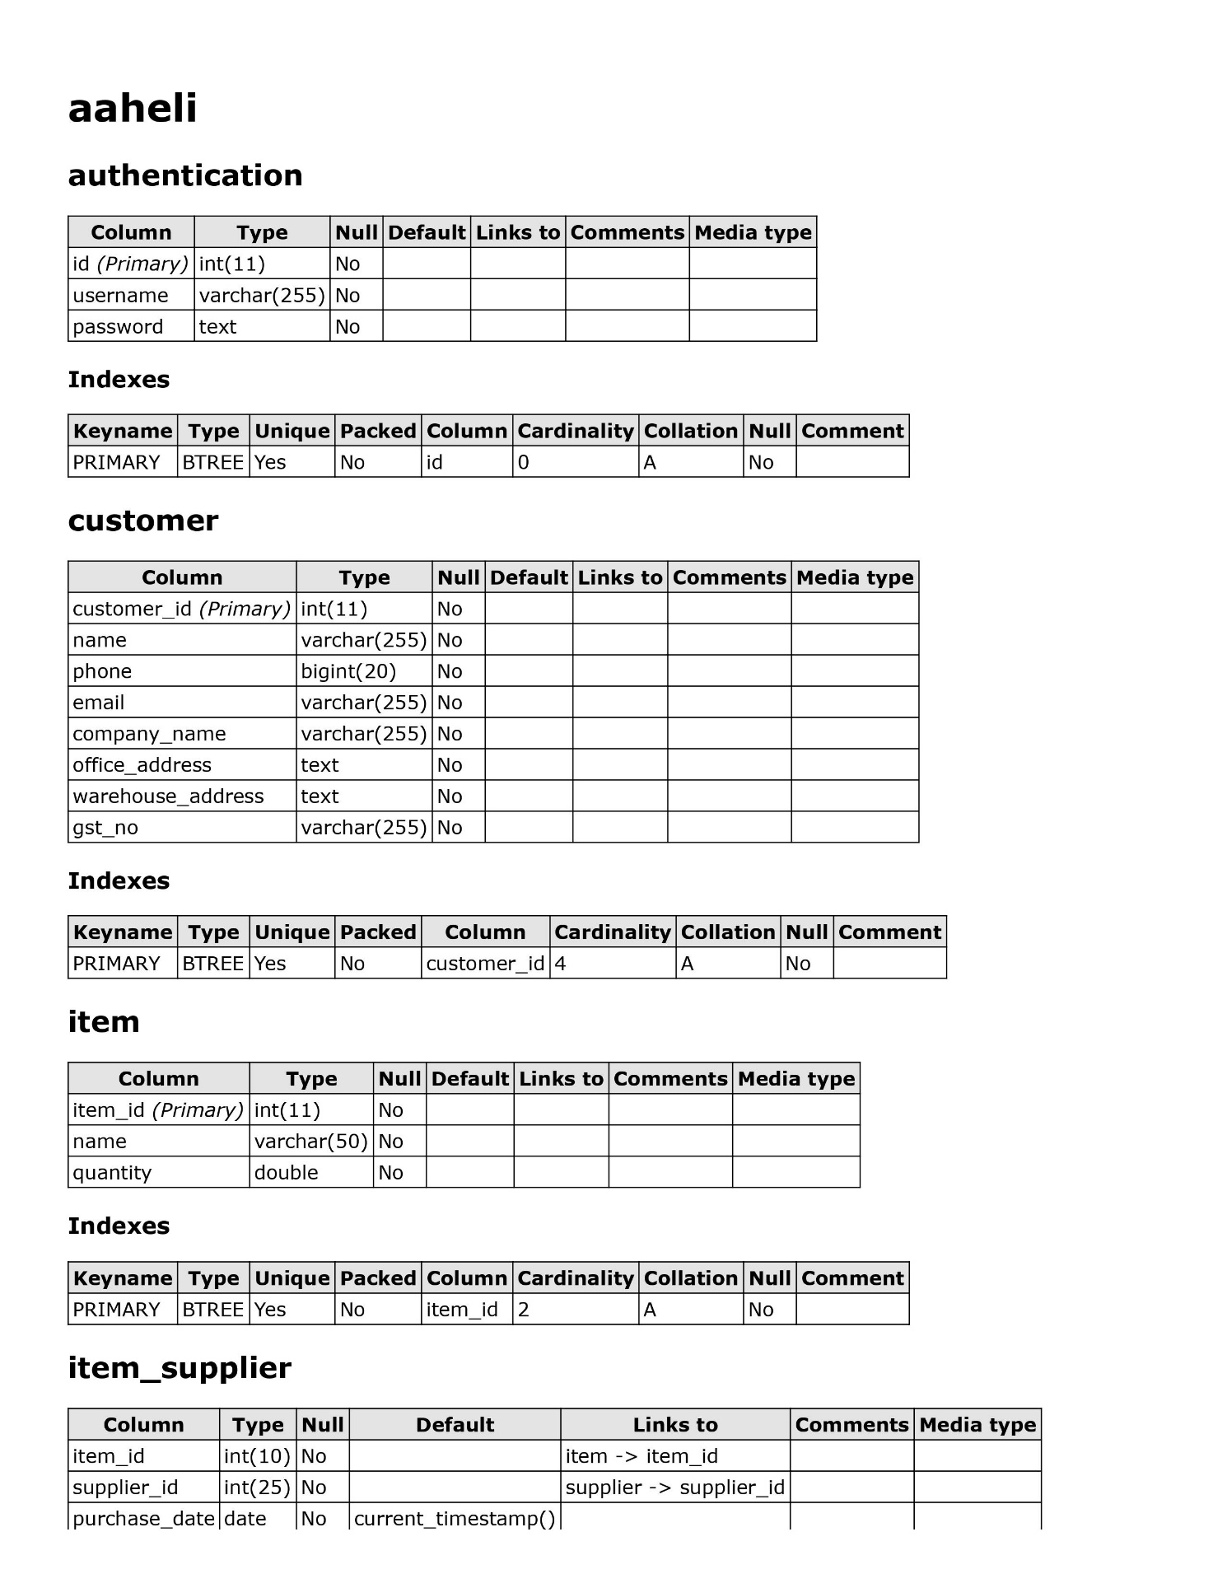**Data Dictionary**

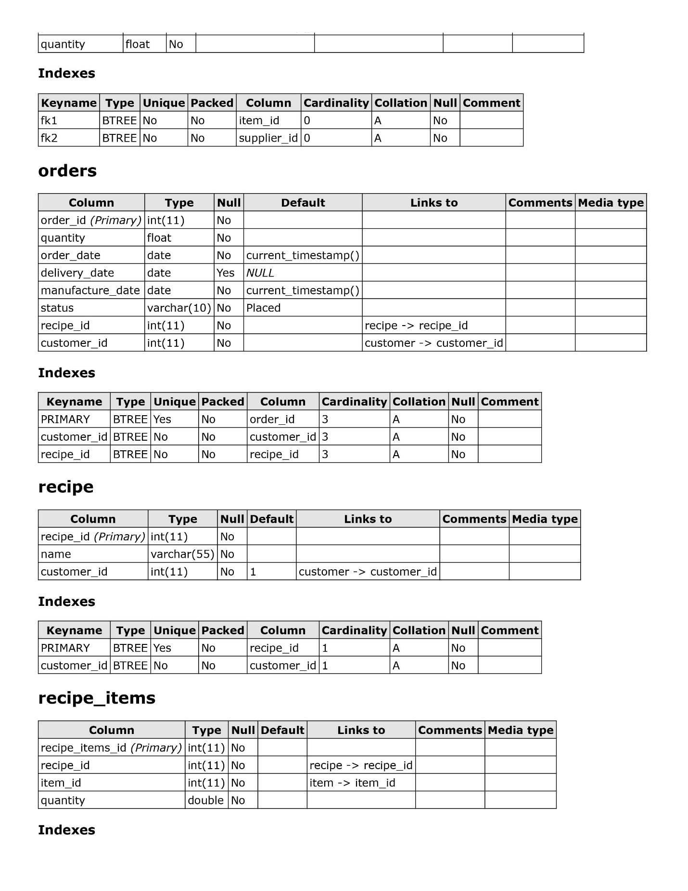

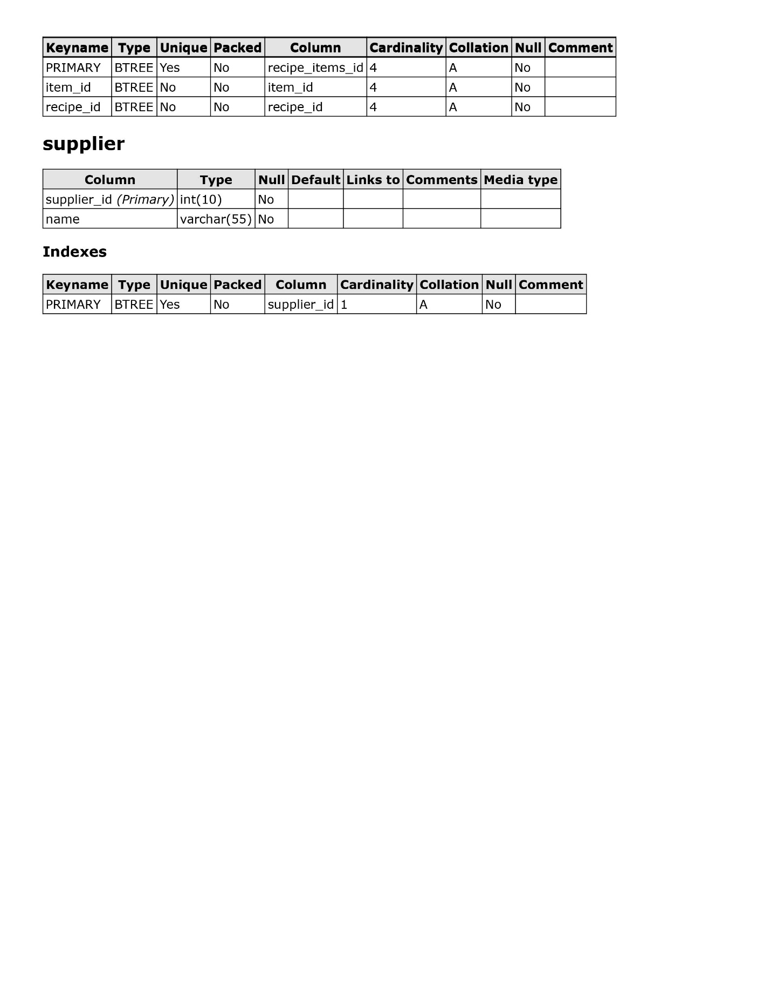

**Input-Output Screen**

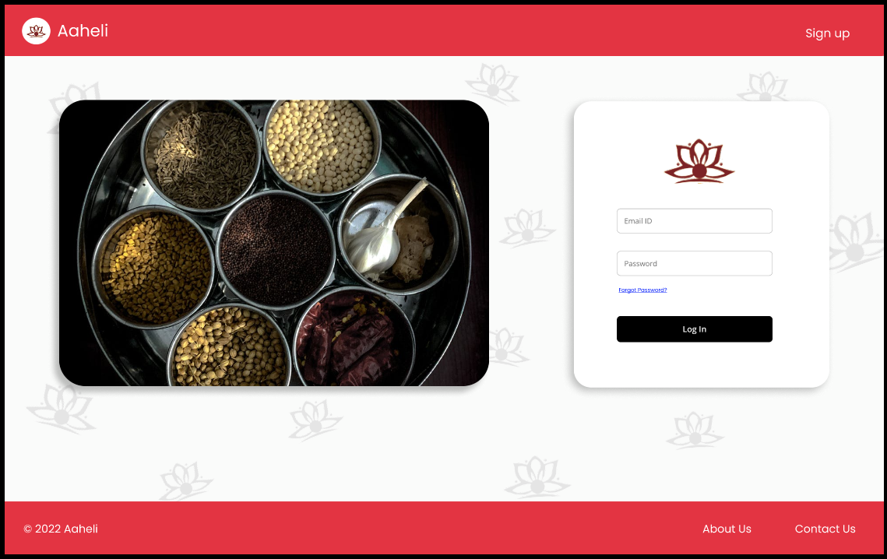

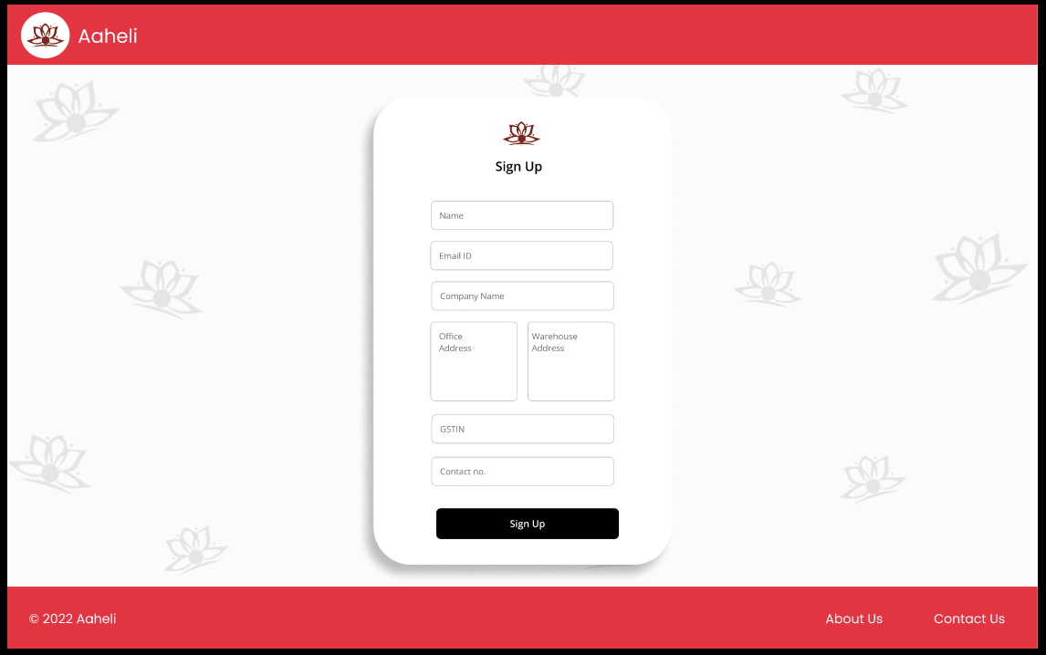

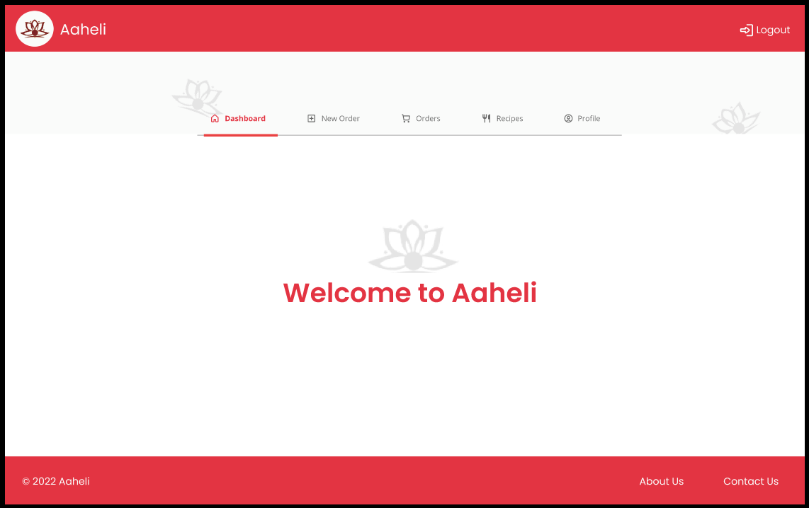

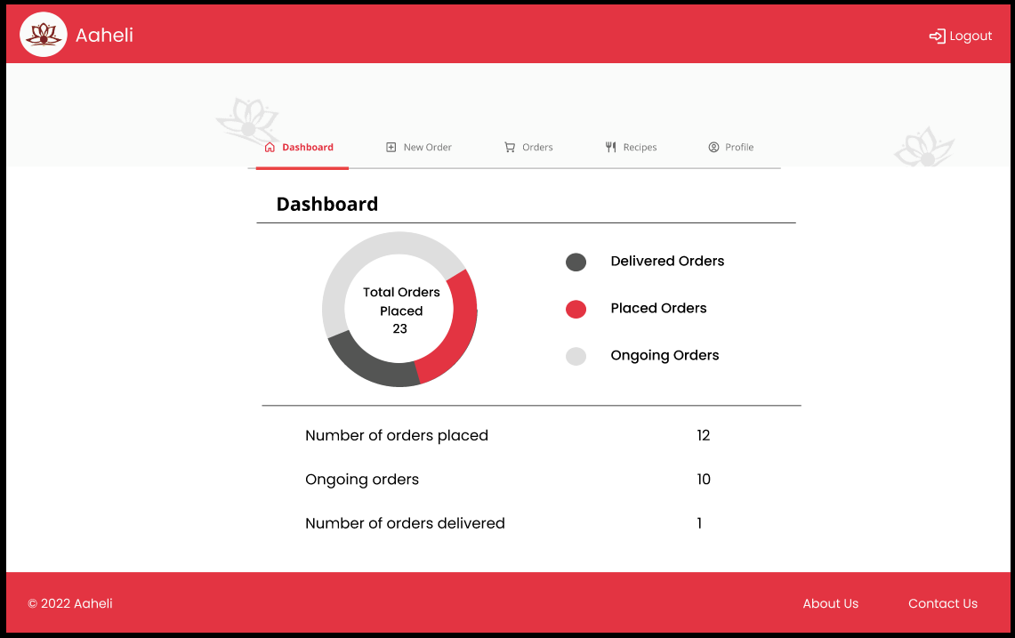

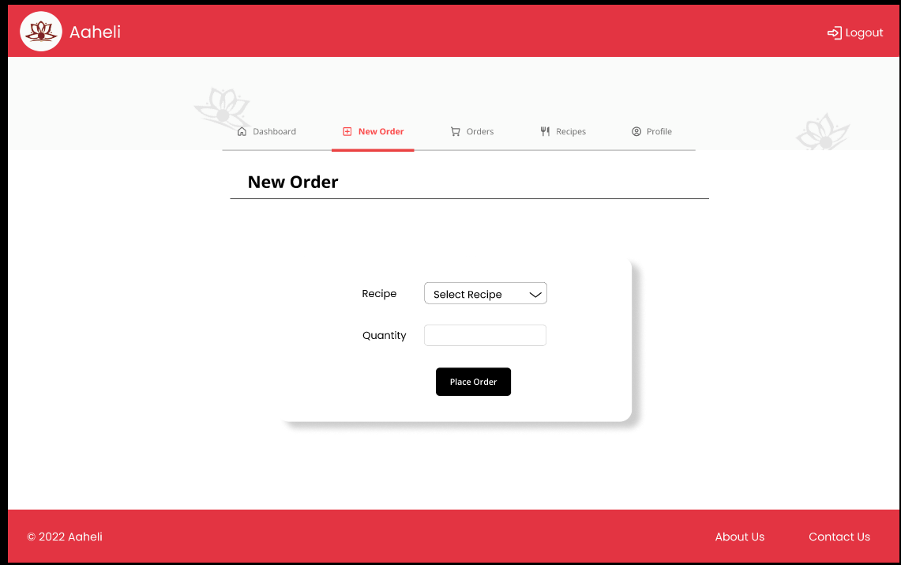

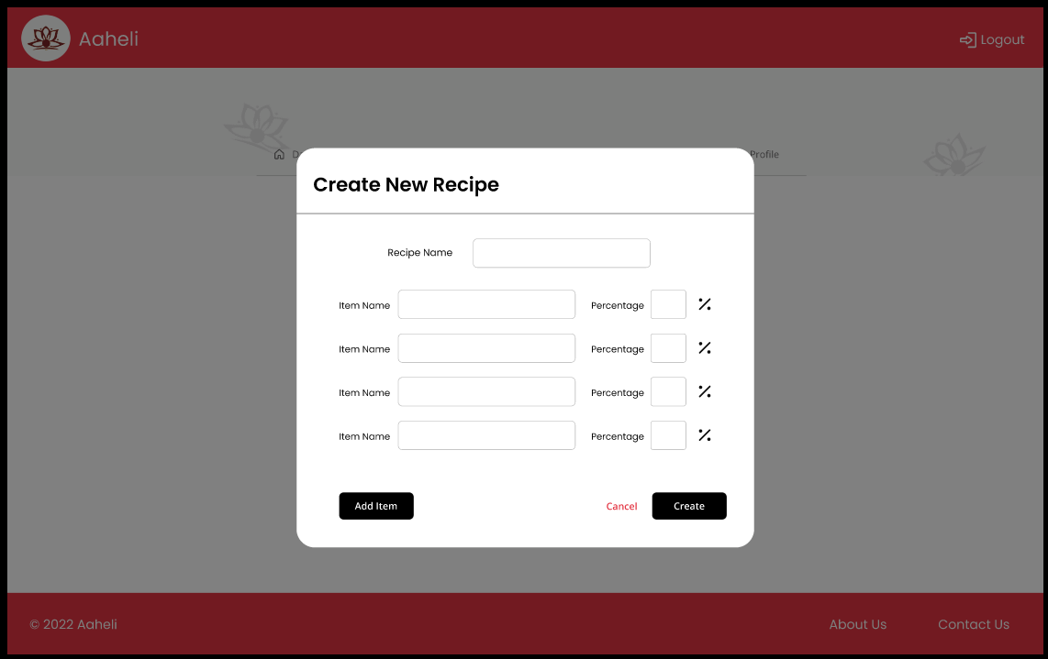

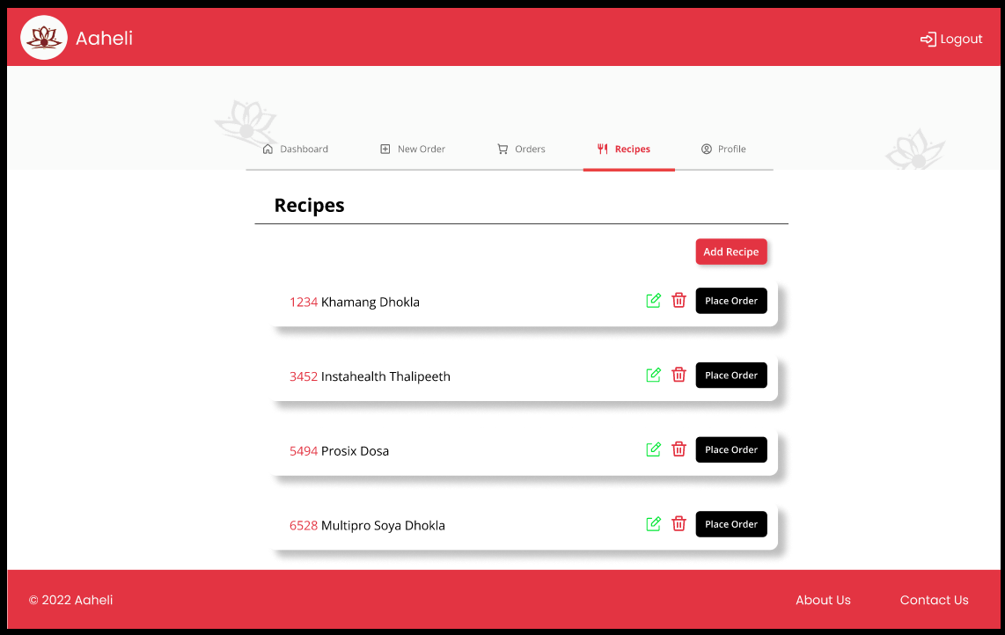

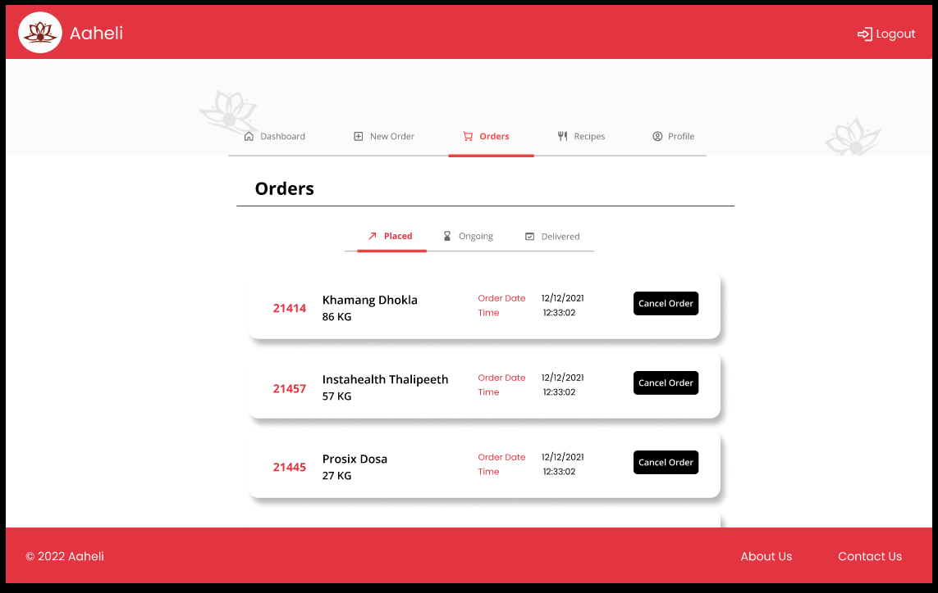

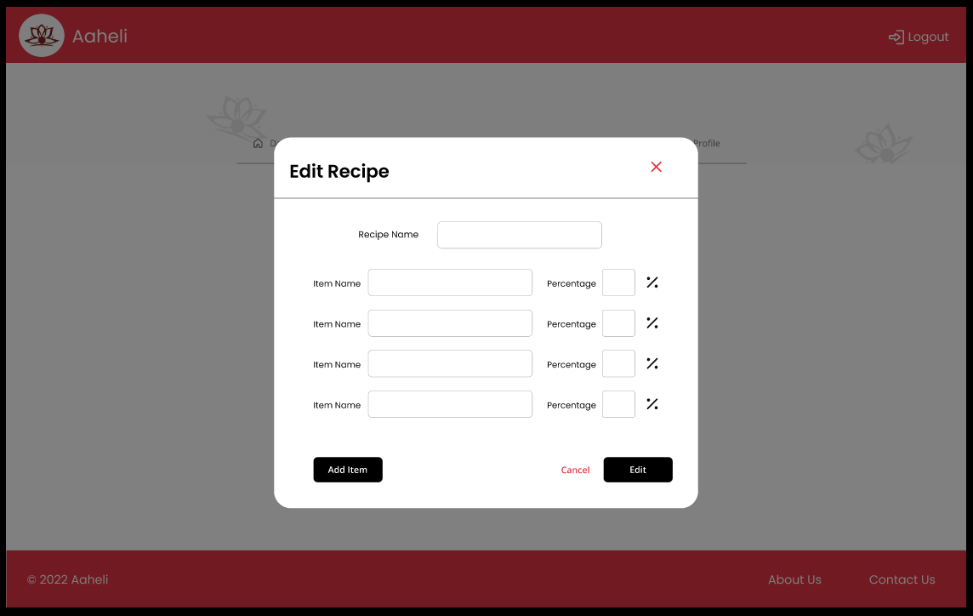

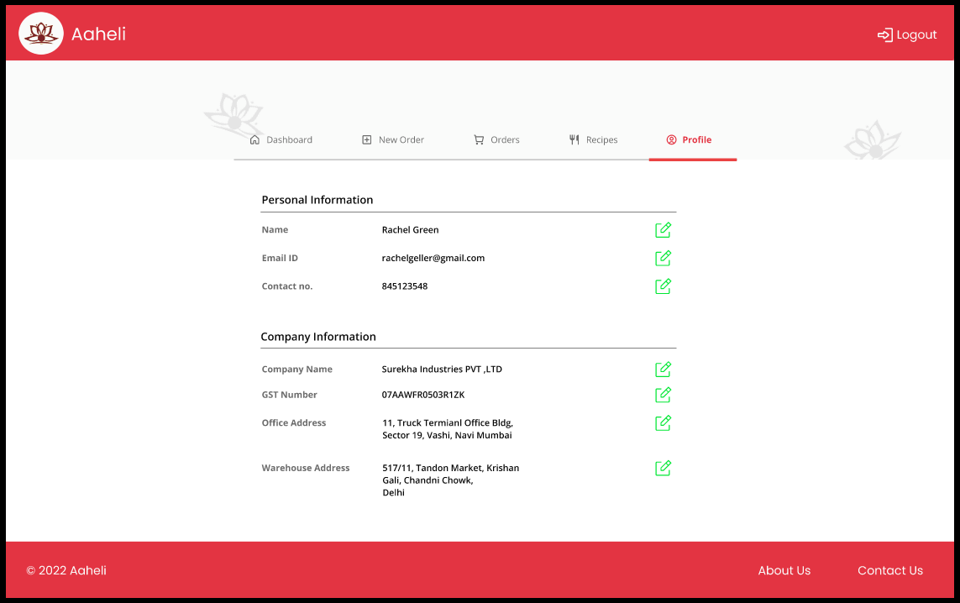

**Limitations and Drawbacks**

* This system is made for laptop and personal computers. So, it would be difficult for the user to use this system on mobile even though it is a web-based application.
* Automations are not done in the system so there is requirement of manual entries to be done.
* Payment mode is not added to the system. So, the clients of the user have to pay through traditional method.
* Creation of purchase order, sales order and other accounting things are not given the deserved priority.
* This system is mainly focused on inventory management system of food manufacturing unit, so generalization of it can’t be done with all the inventory management system.
* Limited test scenarios are considered while creation of the system so future proofing of the system will be an issue.
* This system is lot more focused on Aaheli food manufacturing unit, there methods are given a priority. Some different food manufacturing unit might have some different ideas and methods regarding such system.

**Future Enhancement**

* This system would be made mobile friendly. A mobile application would be made so that it would be more user-friendly.
* Payment mode would be added to the system so that user’s client would pay them through this system only.
* Creation of sales order, purchase order would be done in future updates.
* Automations would be implemented in the future updates so when the stock is about to get under given value, automatic order will be placed.
* Voice recognition and voice reply system would be installed so that user would access the system without touching the computer.
* More generalized perspective would be given for the future updates.
* ML and AI algorithms would be added to understand the patterns in ordering and hovering, to plan more strategies for the user.
* Notification system including SMS updates would be added in future updates for more convivence.

**Bibliography**

* <https://www.figma.com/file/hm2xWknBgEpqr0RYg6RT3c/Aaheli?node-id=0%3A1>
* <https://github.com/kaustubhvkhairnar/aaheli>
* <https://meta.stackoverflow.com/questions/381168/stack-overflow-database-model>
* <https://meta.stackexchange.com/questions/2677/database-schema-documentation-for-the-public-data-dump-and-sede>
* <https://stackoverflow.com/questions/11314373/creating-a-login-system-in-php>
* <https://www.geeksforgeeks.org/how-to-create-admin-login-page-using-php/>
* <https://www.geeksforgeeks.org/how-to-create-a-database-connection/>
* <https://www.geeksforgeeks.org/how-to-read-user-or-console-input-in-php/>
* <https://drawio-app.com/>
* <https://www.google.com/search?q=photo+of+masala+dani&sxsrf=ALCzsYT1_EyPYs-eQDLCW5ntQhvaRUE4w:1652508324459&source=lnms&tbm=isch&sa=X&ved=2ahUKEwisp6udqd73AhUWDd4KHdPWAAkQ_AUoAnoECAEQBA&biw=1280&bih=591&dpr=1.5#imgrc=ms-o4heqAQ8liM>
* <http://localhost/phpmyadmin/index.php?route=/database/structure&server=1&db=aaheli>
* <http://localhost/phpmyadmin/index.php?route=/database/data-dictionary&db=aaheli&goto=index.php%3Froute%3D%2Fdatabase%2Fstructure>
* <https://www.w3schools.com/sql/sql_join_inner.asp>
* https://www.w3schools.com/